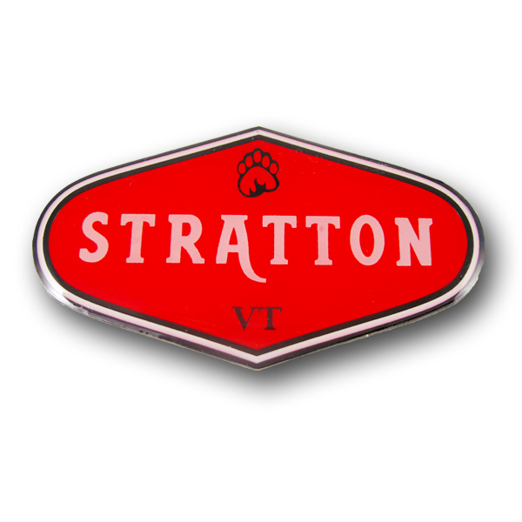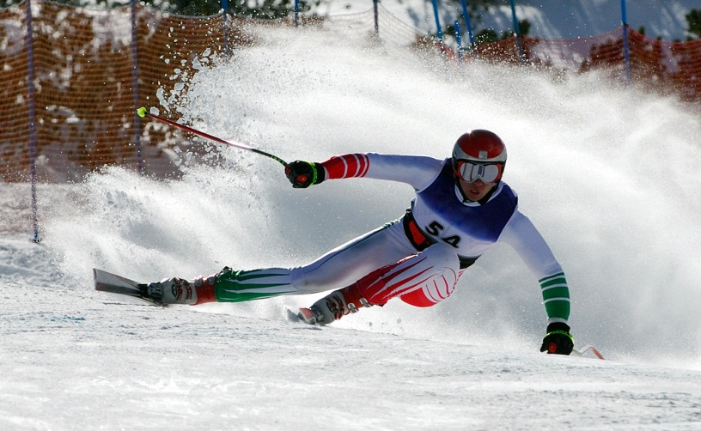

FAMILY SKI MEISTERS 1st Trip of the 2017 Season to
STRATTON MOUNTAIN.
Friday Dec -08th through Sunday Dec -10th

All Packages include:
- 2 nights lodging
- 2-day lift ticket
- All taxes and services
- Vouchers given for “no-snow conditions”
- Fitness center @ $15/day
- Non Skiers subtract $104 for the weekend or $52 per day

Ober Tal:One bedroom
$482.38 per person, based on one person per unit
$292.62 per person, based on two people per unit
$250.87 per person, based on three people per unit
$229.49 per person, based on four people per unit
Mountain Watch:Two bedroom
$337.18 per person, based on two people per unit
$279.91 per person, based on three people per unit
$221.02 per person, based on four people per unit
$209.89 per person, based on five people per unit
$202.47 per person, based on six people per unit

Please give me a headcount and Lodging type as soon as possible (at Oct meeting) so I may secure a group of condos
- check in Friday 5PM, check out Sunday 11AM . Pick keys at Stratton Welcome Center
- check made out to Family Ski Meisters
- Final Payment due at the Nov. Mtg ( give/send to Terrence LoGiurato)
- Room cancellation up to 14 days prior to arrival. ( Nov-24th)
- Sign up on the Family Ski Meisters website or in person at a meeting

