Family Ski Meisters Lake George Gore 2019
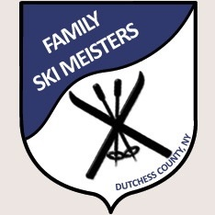
Raul and Cathi DeLeon are hosting the annual 2019 Lake George Gore Mountain Ski Trip on January 4, 5 and 6, 2019.
Step 1. Sign up on the Family Ski Meister Website.
Step 2: Call the Holiday Inn Front Desk: 518-668-5781 for reservations. Mention Family Ski Meisters when making reservations. The room options range from multi room suites to standard rooms. Kids under 12 eat free at the Holiday Inn. The bar hosts a nice happy hour.
Step 3: Complete your Ski Ticket order sheet and return to the DeLeon’s as soon as possible. Bring completed forms to our Holiday Party on December 7th or to the club meeting on December 13th. You can mail your completed forms to:
Cathi and Raul DeLeon
611 Freedom Plains Road
Poughkeepsie, NY 12603
Order forms must be received no later than December 27th. To enhance your trip, the tickets are ordered and paid for in advance, and available to you on Friday night so that your family may hit the slopes bright and early Saturday morning. To do this, once tickets are purchased, we are unable to make last minute changes. Payment is deposited in FSM account and a check is cut by the club treasurer one week before we go. This is why last-minute changes are difficult to accommodate.
West Mountain is nearby and has night snow tubing. The outlet centers can satisfy all your shopping needs. As well, Family Ski Meisters get together for wine and cheese and games Friday and Saturday nights. The hotel has a heated indoor pool as well as an outdoor hot tub. Fun for all.
For any questions, please call Raul 845-518-7276. We look forward to another wonderful ski trip.

